Assignment – 1

• Install Power BI Desktop and share the final screenshot of the report view page which appears when power desktop starts.

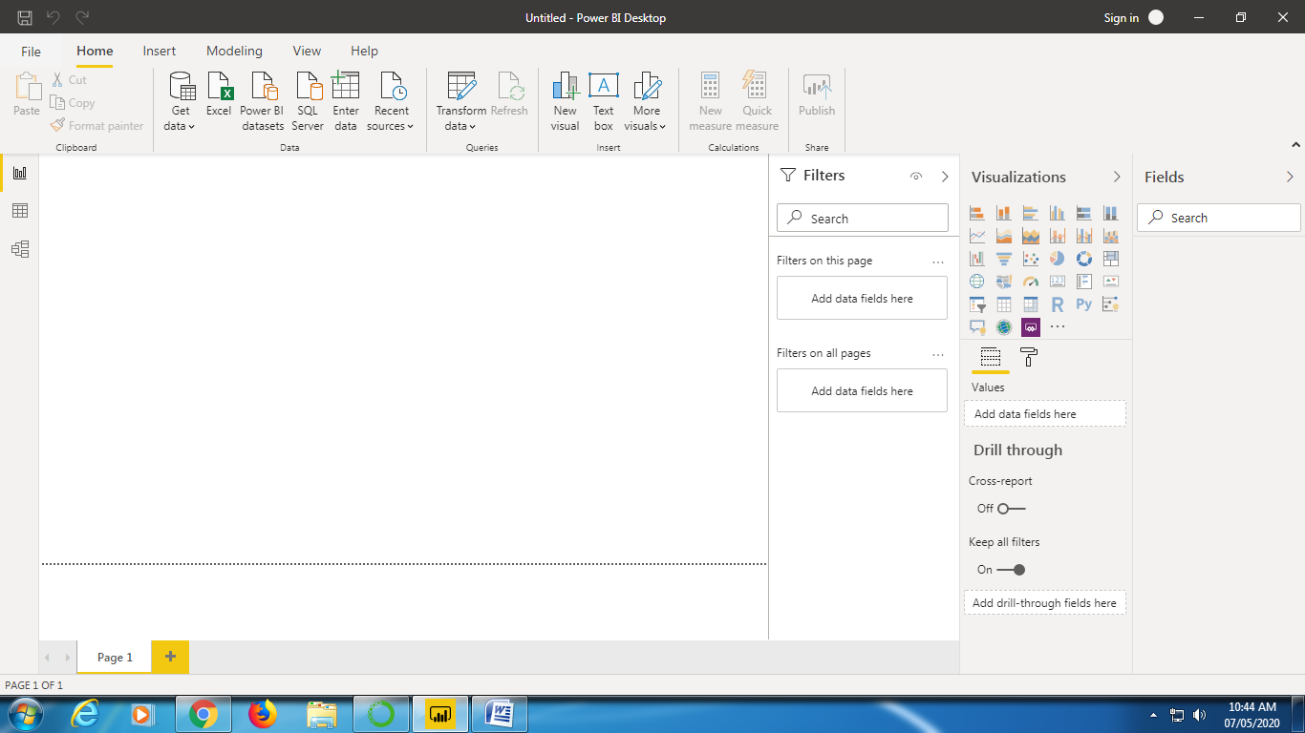

• Prepare a document and with the following screenshot

− Report View

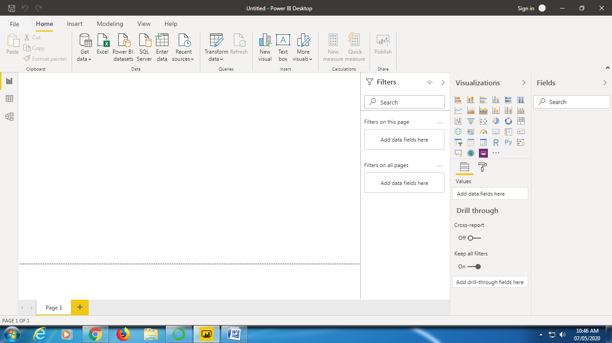

− Data View

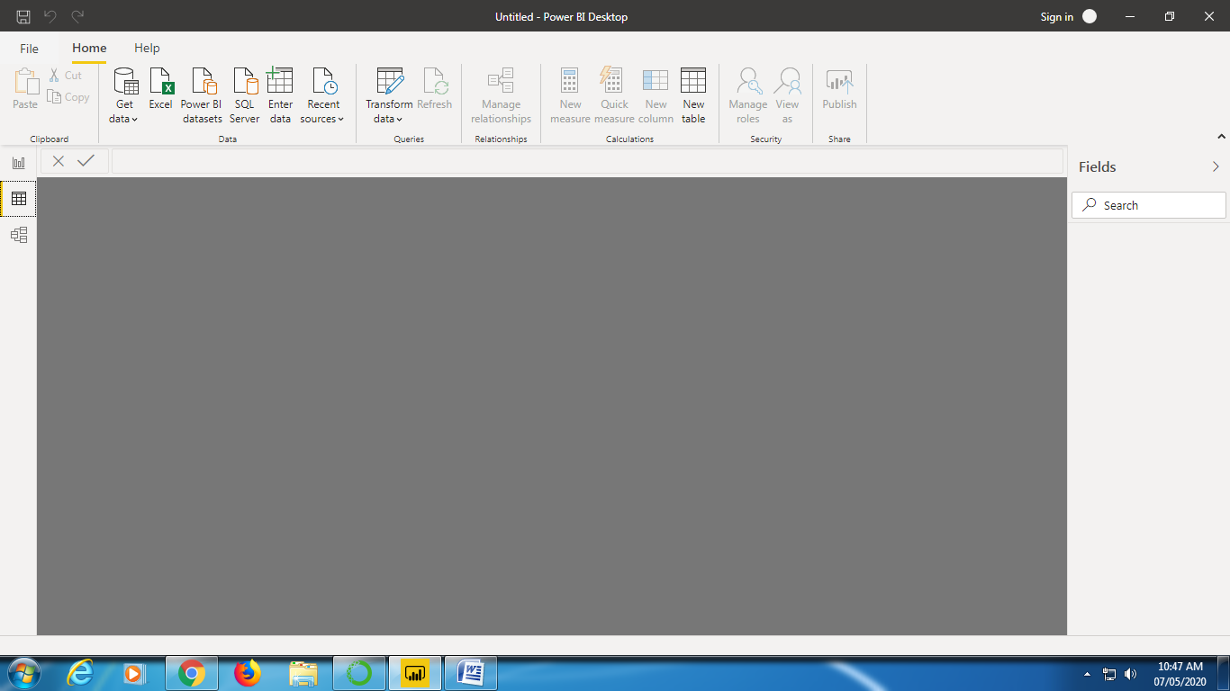

− Model View

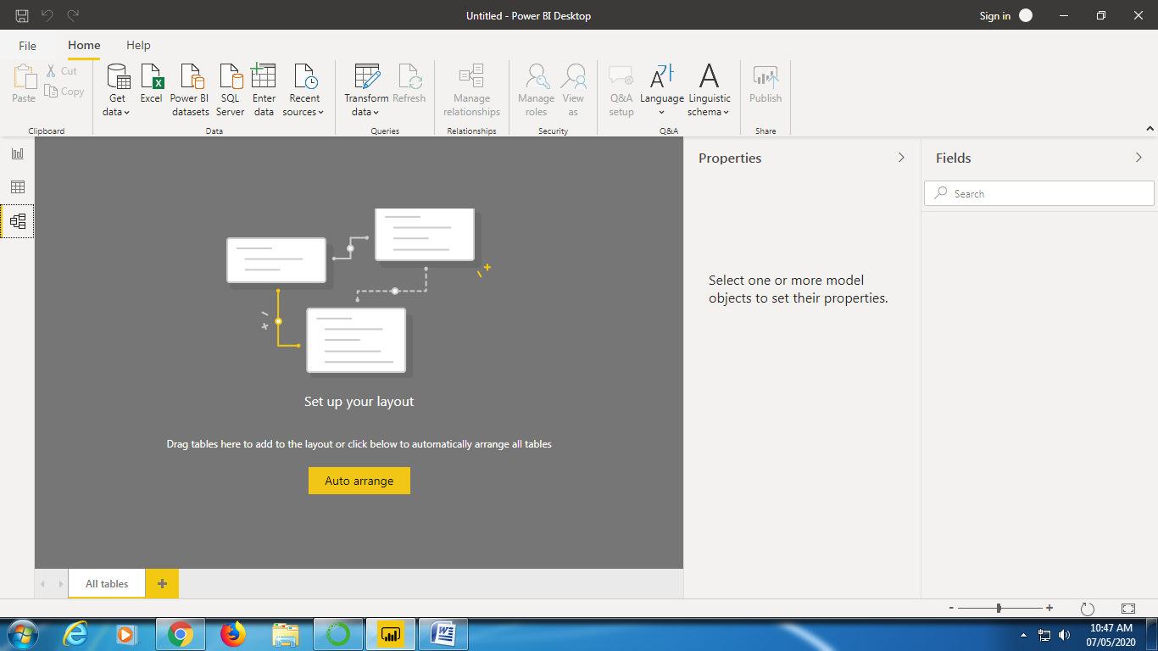

− Power Query Editor

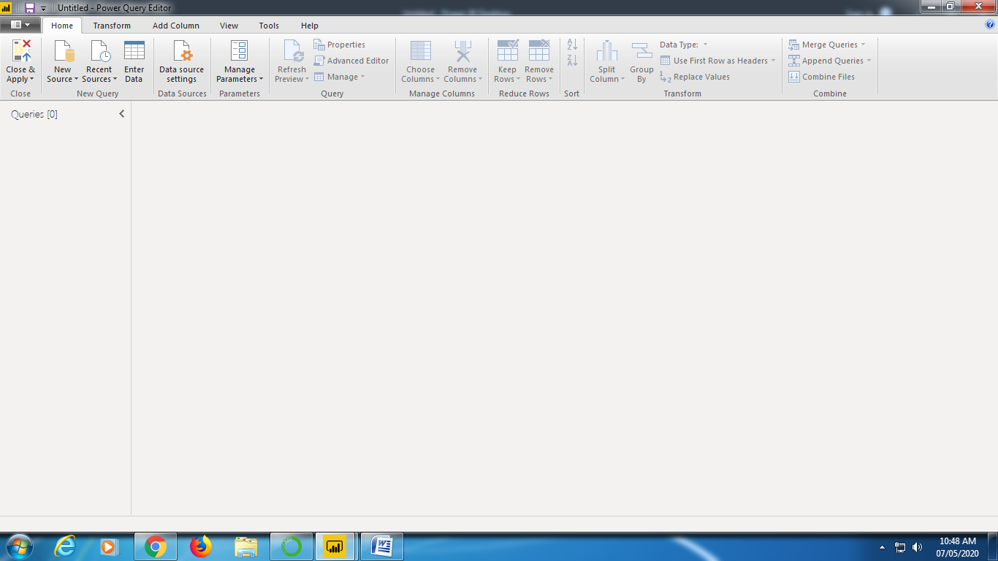

− Advance Editor

• Prepare a document with details of the following along with their pri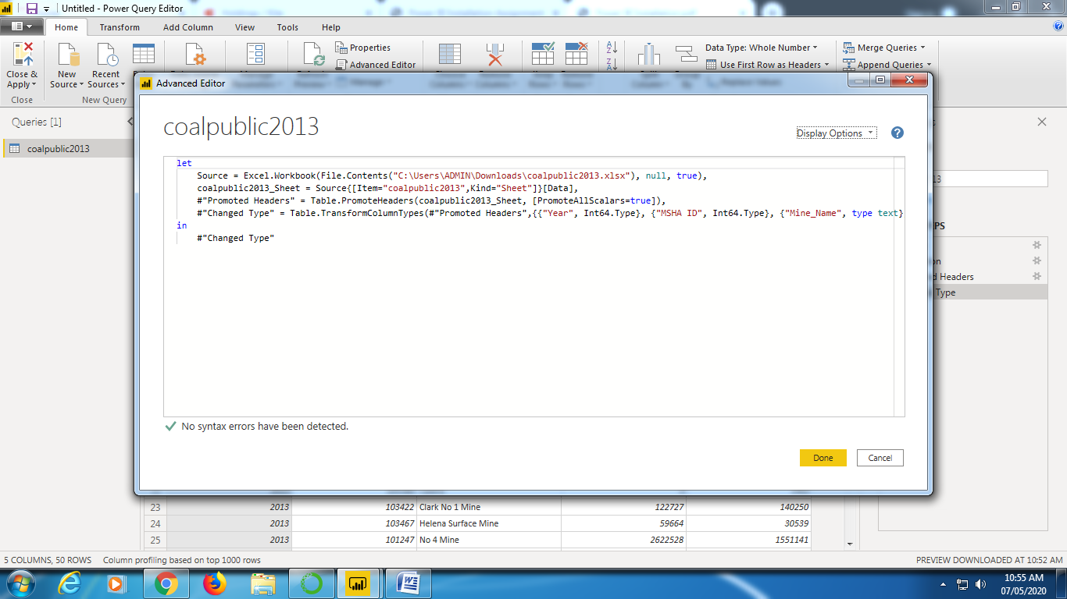

• Prepare a document with details of the following along with their price− Power BI Desktop − Power BI Pro − Power BI Premium

Microsoft PowerBI Official link for features and pricing:

<https://powerbi.microsoft.com/en-us/pricing/>